Synchronous Transmission: In Synchronous Transmission, data is sent in form of blocks or frames. This transmission is the full-duplex type. Between sender and receiver, synchronization is compulsory. In Synchronous transmission, There is no time-gap present between data. It is more efficient and more reliable than asynchronous transmission to transfer a large amount of data.
Example:
- Chat Rooms
- Telephonic Conversations
- Video Conferencing
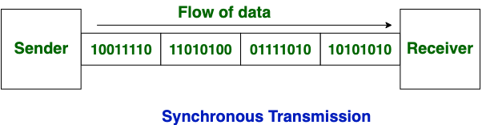
Asynchronous Transmission: In Asynchronous Transmission, data is sent in form of byte or character. This transmission is the half-duplex type transmission. In this transmission start bits and stop bits are added with data. It does not require synchronization.
Example:
- Email
- Forums
- Letters
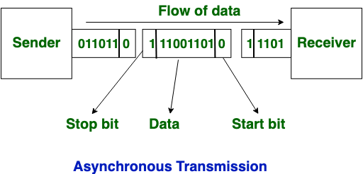

Now, let’s see the difference between Synchronous Transmission and Asynchronous Transmission:
S. No. | Synchronous Transmission | Asynchronous Transmission
1. | In Synchronous transmission, data is sent in form of blocks or frames. | In Asynchronous transmission, data is sent in form of bytes or characters.
2. | Synchronous transmission is fast. | Asynchronous transmission is slow.
3. | Synchronous transmission is costly. | Asynchronous transmission is economical.
4. | In Synchronous transmission, the time interval of transmission is constant. | In Asynchronous transmission, the time interval of transmission is not constant, it is random.
5. | In this transmission, users have to wait till the transmission is complete before getting a response back from the server. | Here, users do not have to wait for the completion of transmission in order to get a response from the server.
6. | In Synchronous transmission, there is no gap present between data. | In Asynchronous transmission, there is a gap present between data.
7. | Efficient use of transmission lines is done in synchronous transmission. | While in Asynchronous transmission, the transmission line remains empty during a gap in character transmission.
8. | The start and stop bits are not used in transmitting data. | The start and stop bits are used in transmitting data that imposes extra overhead.
9. | Synchronous transmission needs precisely synchronized clocks for the information of new bytes. | Asynchronous transmission does not need synchronized clocks as parity bit is used in this transmission for information of new bytes.
10. | Errors are detected and corrected in real time. | Errors are detected and corrected when the data is received.
11. | Low latency due to real-time communication. | High latency due to processing time and waiting for data to become available.
12. | Examples: Telephonic conversations, Video conferencing, Online gaming. | Examples: Email, File transfer,Online forms.

